**Lab Problem 1**

Here is what I got from the plot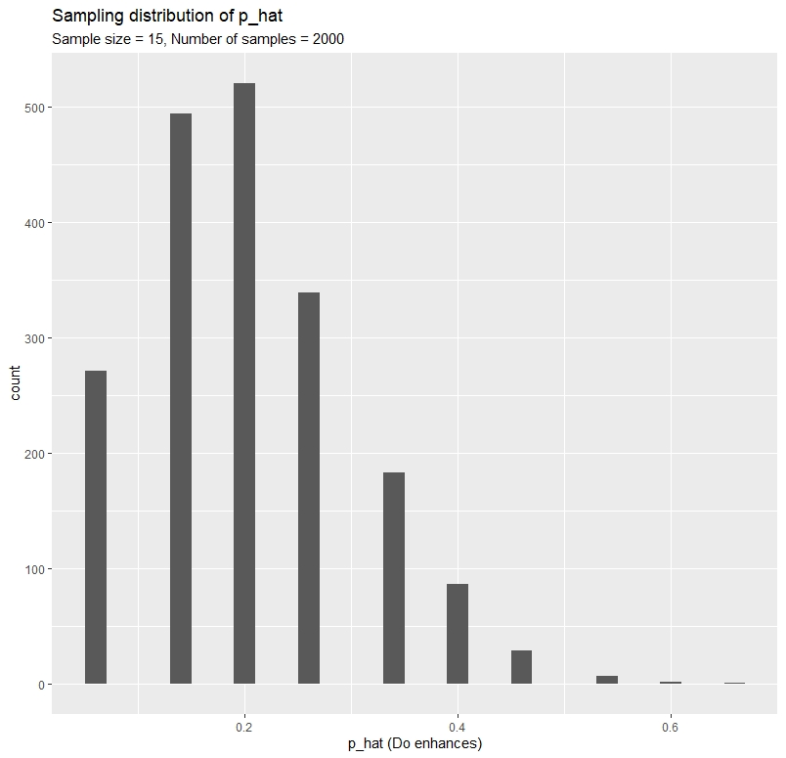

It’s absolutely right skewed graph

**Lab Problem 2**

This one is symmetric

